Báo cáo Lab01 thực hành lập trình hướng đối tượng.  
  
Nguyễn Thành Đạt – 20204947  
  
**2.2.1 First Java application**

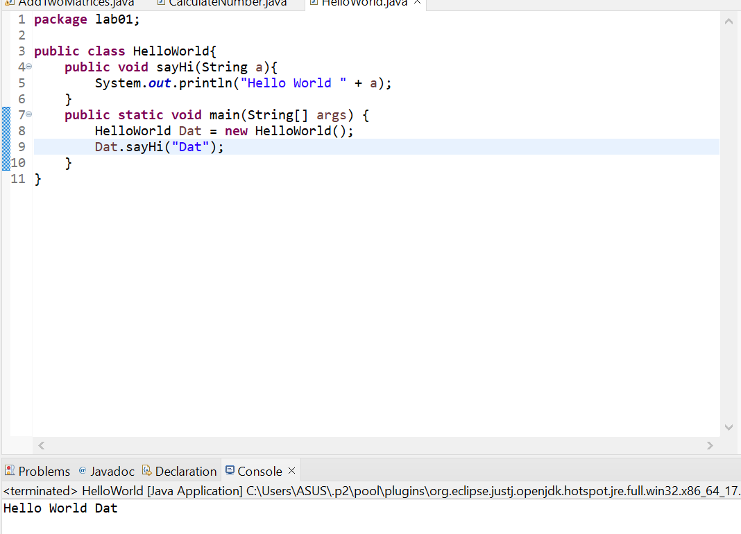

**2.2.2 First Dialog Program**

**2.2.3 First Input Dialog Program**

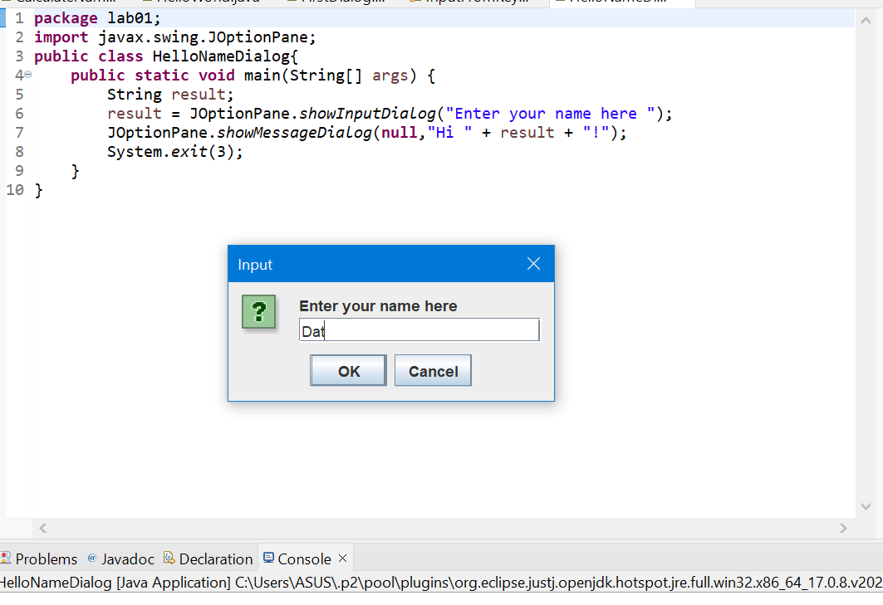

**2.2.4 Run ShowTwoNumber.java example**

**2.2.5 Caculate Program**

**2.2.6 Solve Equation Program**

**6.1 Choosing Option**

**6.2 Input/Output from keyboard  
**

**6.3 Display Triangle**

**6.4 Display Number Day Of Month**

**6.5 Sort Array**

**6.6 Add Two Matrices**

